*****************************************************************
PREFERED FTP CLIENT


If you are going to be ftping files on a regular basis we strongly recommend you download and use FileZilla from http://filezilla-project.org/ . It is a free download. Documentation for installation as well as usage can be found at http://wiki.filezilla-project.org/Documentation

FileZilla can also be downloaded from PortableApps (http://portableapps.com/) and installed on your Flash Drive if you use PortableApps (http://portableapps.com/news/2009-03-27_-_filezilla_portable_3.2.3.1)

FileZilla is already installed in all the classrooms on the 4th floor of the ATLC. You will find it under Utilities

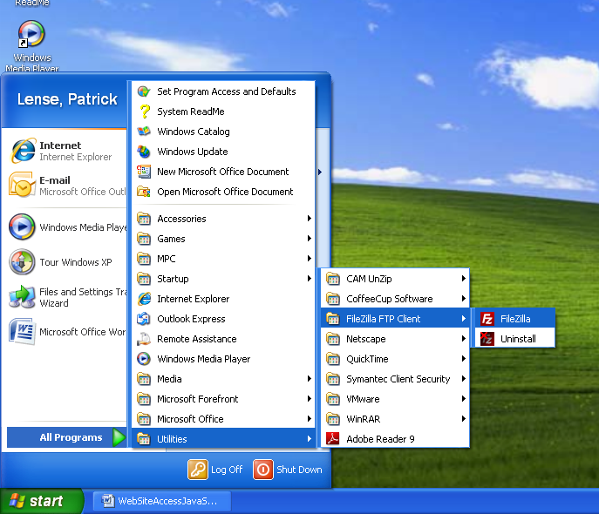
Accessing/transferring your files (FTP) using Filezilla

When you first open FileZilla you should get a screen that looks like this.
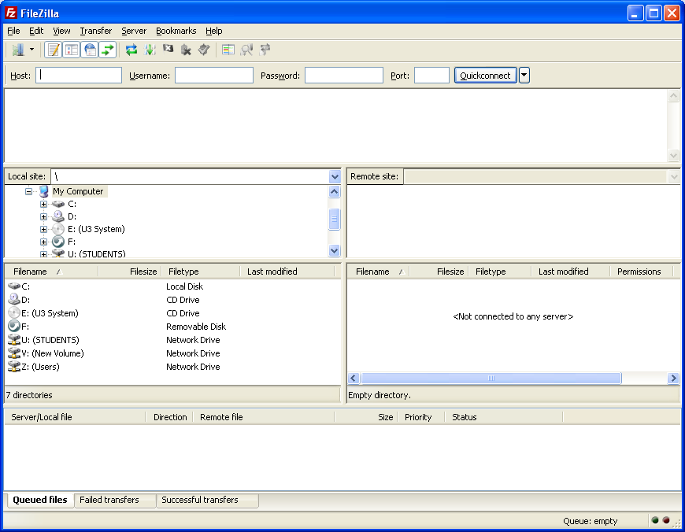

So that you do not have to enter all the information every time you want to ftp I recommend you create a site in the site manager. (File -> Site Manager – or click on the first icon in the tool bar)
Fill in name
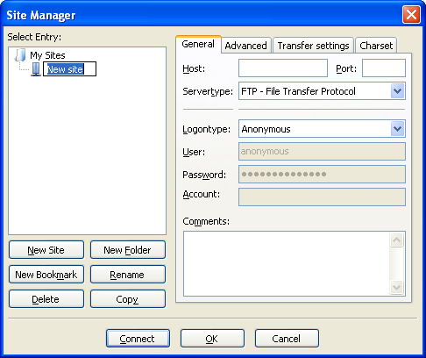

Once you have the site manager open click on New Site and give the site a name.
In the General Tab on the right complete the following:

HOST: itd1.cincinnatistate.edu
LOGONTYPE: Normal
USER: Same user name you use to log on to computers at school
HOWEVER you must put cincinnatistate\ in front of it.
Example: cincinnatistate\RSmith
PASSWORD: The password is the same as you use to log on to computers at school
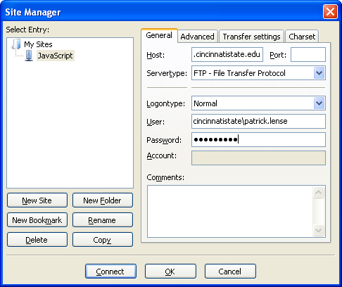

When you have those fields filled in click Connect. This will save the information and connect you. In the future then you can merely choose you site from the dropdown arrow on the first icon to connect to your site.

Once you are connected you should see a screen that has “Directory listing successful” at the bottom of the top pane and looks like this:
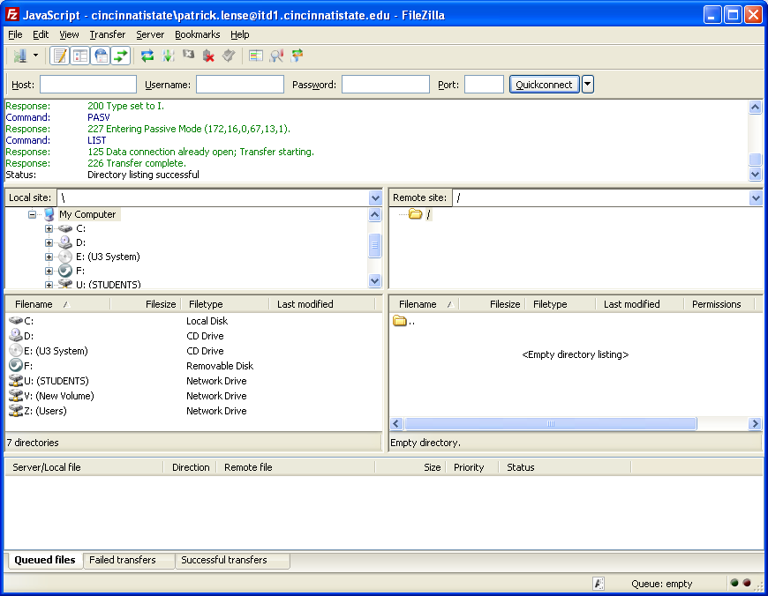

Next on the right side you will see a text box that says “Remote Site”.
After the forward slash type HTMLxxx-Your last name and last 4 digits of your Student ID
The xxx represents the section of IT-110 you are in.
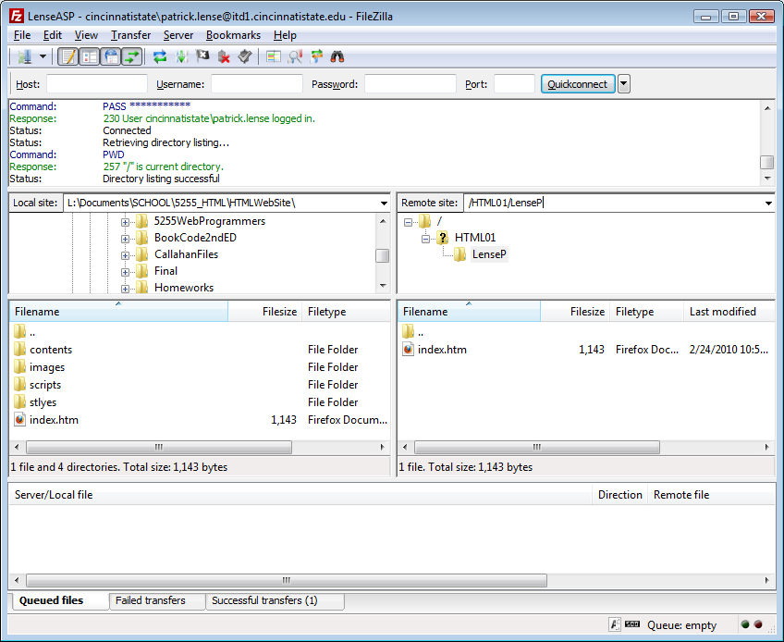
If your name was Pat Lense, your Student ID was 0123456, and you were in IT-110-400, then the Remote Site box would contain:

/HTML400-Lense3456
/HTML400-Lense3456

After you enter that press the Enter key and your files will be displayed in the window below it.
Local working files
Files on Server
/HTML400-Lense3456

On the left side is your local file directory. Navigate to where your working files are so that they appear in the bottom pane on the left. To transfer files back and forth between the server and your local disk merely drag them from one window to the other. The very bottom pane will indicate which files are being transferred and the direction of the transfer as well as the progress of each transfer. When that pane is empty again the transfer was complete.
Viewing your site (HTTP)

NOTE: yourfoldername = Your Last Name and First Initial of your first name. EG: Rick C Smith ➔ SmithR

In your Browser Address box type:
http://itd1.cincinnnatistate.edu/HTMLxxx-yourfoldername
Again the xxx represents the section of IT-110 you are in
eg: If you were Pat Lense, with Student ID of 0123456, and in IT-110-400 then the URL would be:

Once you enter that URL you should see the page as depicted below
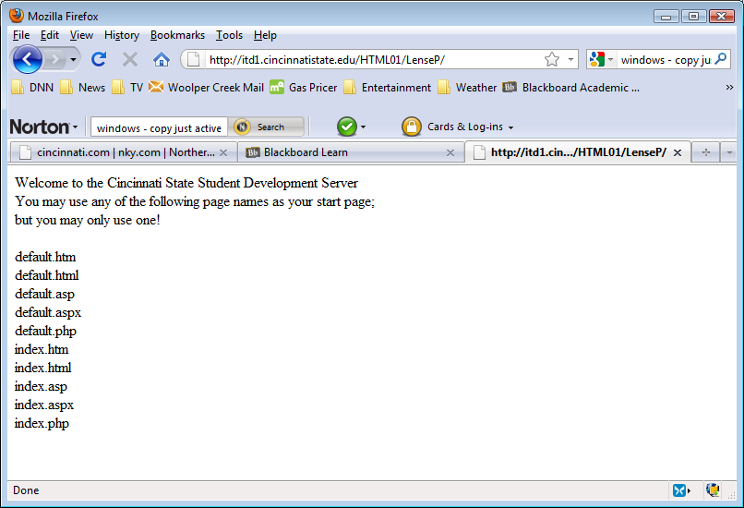
http://itd1.cincinnnatistate.edu /HTML400-Lense3456

